Private Idaho
User's Manual
Preliminary Draft

What is Private Idaho? 4
Getting Started 5
Configuring the Server Options 5
Managing your Mail Folders. 5
Drafts Folder 6
Outbox 6
Sent Items 6
InBox 6
Creating a Node Folder 7
Creating a Sub-Folder 7
Sending your first message. 7
Attaching a File or Picture 8
Encrypting a Message 8
Encrypting using a key 8
Encrypting an Attachment or Picture 9
Conventionally Encrypting a Message 9
Advanced Encryption Options. 10
Signing a Message 10
Clear Signing a Message 10
Encrypting and Signing a Message 11
Adding a key to the MIT key server 11
Requesting a key from the MIT key server 11
Remailers 13
Installing and Using a Type I Remailer 13
Obtaining the Remailer Keys 14
Sending a Message Using a Type I Remailer 14
Installing and Using Mixmaster (Type II Remailer) 14
Sending Attachments through Remailers 15
Creating a Nym 17
Adding Remailers 19
Scanning for PGP Messages 19
MailBox Facility 19
How Messages are Stored in the Database 20
How Attachments are Stored in the Database 20
Posting a Newsgroup Message 20

What is Private Idaho?
Private Idaho is an E-mail client that has evolved to incorporate utilities which can assist you in your need for privacy.
Private Idaho uses the Pretty Good Privacy (PGP) encryption library to encrypt all its messages. It therefore does not include any internal encryption routines at all.
If you would like to read a very good book on the background to PGP, then get a copy of SImson Garfinkel's book PGP Encryption for Everyone published by O'Reilly & Associates. This book was written to cover the an earlier version of PGP, that is PGP 2.6.x, however it is still very relevant.

Getting Started
After you have installed Private Idaho you must configure it. The main items you must configure are those that allow you to access your mail. First of all, dial your ISP and log onto the Internet. The purpose of this step is for you to be able to access your mail server.

Configuring the Server Options
To configure Private Idaho, click on the Tools:Email Options menu item. From there, fill in the details as shown below as they apply to you. Note if you are using Exchange then you should be aware that you will likely have a different SMTP and POP3 address. Just remember that your log-on ID for exchange will be something like, <nt domain>/<your id>, for example ntdomain/mjones

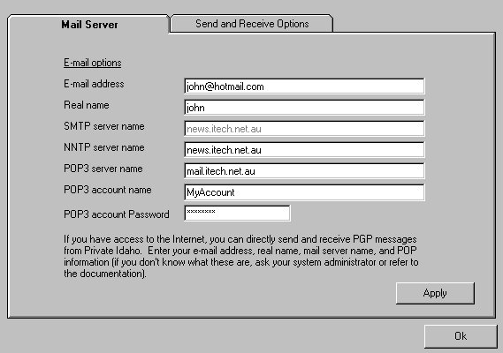

Managing your Mail Folders.
Private Idaho's mail folders are very similar to MS Outlook's. You may drag and drop between folders. The default folder names are obvious. All deleted messages first go to the Deleted Items folder, and the deletion is permanent if a message is deleted from the Deleted Items folder. The following is a description of the System Folders.

Drafts Folder
The drafts folder is where messages are stored that are in the process of being written. To store messages here, just click on the Save button icon.

Outbox
The Outbox is where messages are temporarily stored while waiting to be sent. When you send a message, it is first stored here and will be when Private Idaho next scans for messages. This scan period can be set under the Tools:Email Options menu item. If you wish to send the message without waiting for the next scan period, then click on Tools:Send and Receive Messages.

Sent Items
This folder will contain messages that were successfully sent. You can drag and store them to other folders if you wish.

InBox
The InBox will contain all incoming messages. If a message is determined to be encrypted then you will see a closed envelope with a key on top of it.

Description of Inbox Message Icons
The following table gives a description of the icons used in the Inbox.
Icon | Read | Plain Text | Encrypted
Eye with Closed Envelope | No | Yes | No
Eye with Open Envelope | Yes | Yes | No
Key with Closed Envelope | No | No | Yes
Key with Open Envelope | Yes | No | Yes
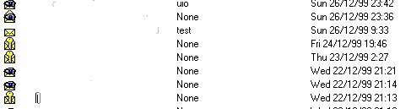

Creating a Node Folder
A node folder can be created by right clicking the mouse button or clicking on the folder icon on the toolbar.

Creating a Sub-Folder
A sub folder is created by clicking on a Node folder and then right clicking the mouse button.
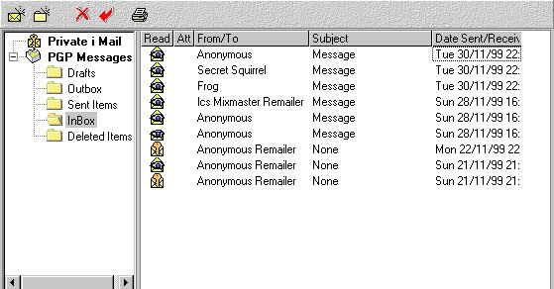

Sending your first message.
Once the intial setup is complete click on the Apply button and Private Idaho is ready to run as normal email client. To test it, click on the compose butto non the tool bar above and compose a message and then type in the E-mail address of the person you wish to send the message to. As this is a simple test, make sure that the remailer drop down list shows Don't Use Remailers. If all is okay, press the Send button (Envelope Icon) and the message will be transferred to your Outbox. The message will be sent next time Private Idaho scans for incoming messages. If you want the messages sent straight away, then click on the Tools:Send and Receive Messages menu item. If you sent the message to yourself, you should see the message returned in your inbox, this is because PI scans for new messages after it has sent a message. If you want to view it then double click on the message and it will open so that you can read it. Practice this to make sure you understand the process before proceeding to more advanced work involving remailers and encryption.

Attaching a File or Picture
A file or picture can be added by either draging and droping the item into the message area, or by clicking on the paper clip button on the toolbar. The message is encoded using the standard MIME format. Should you receive a message through a remailer or other source that does not understand MIME, you can decode it using Private Idaho's MIME decode utility which is the green particle box on the main toolbar. If you wish to send an attachement through a remailer you should refer to the section Sending Attachments through Remailers.

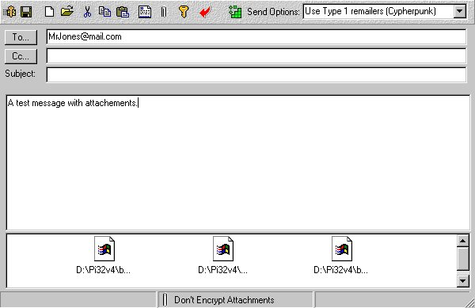

Encrypting a Message
Before you can encrypt a message you must have PGP version 5 or 6 installed. If you installed Private Idaho without PGP installed you will notice that there is no PGP menu. To fix this install PGP. Once you have done this, close down Private Idaho and restart it. If all was okay, you should the PGP menu, if not go to the menu File:Enable PGP and Utilies. You should now see the PGP menu.

Encrypting using a key
Okay, here is how it works. After you have created a message you will want to either encrypt, sign it or encrypt and sign it. Let's start with encrypting the message. If you go to the PGP:Encrypt Mesage menu item without a recipient in the To field, you will obtain an error. This is because Private Idaho is looking for the Key ID of the recipient. To fix this click on the To: button. If you have the recipient's public key on your key ring you should see it after you select the drop-down box item "Public Keys" shown below. Select the recipient and click okay, the receipient's email address should now appear in the To: box and the message will have been encrypted with that person's public key. The only person who can de-crypt the message now is the owner of the public key. He will do this by using his matching private key. So you can now send the message to him directly or through a remailer.

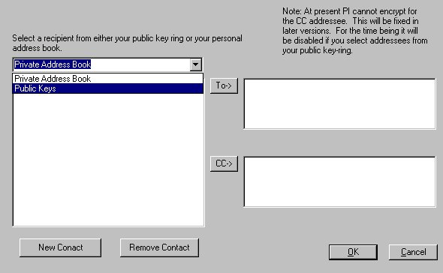
Encrypting an Attachment or Picture
A file or picture can be added by either draging and droping the item into the message area, or by clicking on the paper clip button on the toolbar. Once it has been added to the attachment list you have the option of sending it as part of the message either encrypted with a key, conventionally encrypted or unencrypted. Each of these options is available through the main menu item under PGP:Encryption Options:Attachments Encryption Options.

Conventionally Encrypting a Message
There may be times when you wish to use a conventional encryption technique. This basically means that the message will be encrypted with a passphrase. This means that only you will be able to decrypt message. If you wish to send this encrypted message to someone else, then you will need to tell them the passphrase. This is very different from Public Key Encryption where you rely on the recipient having a public key that you can use.
To conventionally encrypt a message you must first set the conventional encrypt option (see screen capture below). Now just copy or type the text into the message area and then go to the menu PGP: Encrypt and the message area will be encrypted. If you have selected the Files Operations you will be given the option of saving the encrypted information to a file.

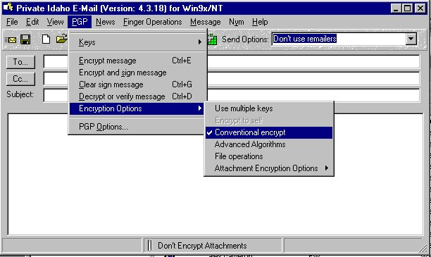
Advanced Encryption Options.
Private Idaho gives you an option of using other Ciphers and Hash algorithms when encoding messages. You can view these by clicking the PGP:Advanced Algorithms menu item.

Signing a Message
Signing a message is authenticating that the message was sent by you and also allows the user to verify that the text of the message was not altered by anyone during transit. You have the option of Clear Signing and Encrypting and Signing. This is very useful for authenticating legal documents

Clear Signing a Message
If you Clear Sign a message you leave the original text unchanged but add below it a signature block indicating you composed the message and allowing the receipient to authenticate that the message has not been tampered with. Before you can sign a message, PGP must confirm you own the key that you are using to sign the message (for obvious reasons) so you will be prompted to enter the passphrase of the key you are going to sign with. In this way your ownership of the key is validated.
If you wish to use a default key for signing messages, rather than selecting a key each time, then go to the menu PGP:Options and select the key you wish to use. This key will be saved and used until you revoke it. Below is an example of a clear signed message.

-----BEGIN PGP SIGNED MESSAGE-----

This is a test message

Now is the time for all good men to come to the aid of the party.

-----BEGIN PGP SIGNATURE-----
Version: N/A
Comment: Signed by Key 0x706B2059

iQCVAwUBOEg80PsDNR9wayBZAQEWEgP+KwNaMq2yjJ9DEw9UtJs3iD8BO3u3BHGn
5MBukV71jnpEKnMtp1RYAUdq97IrRrNpoMtgr6jsLEk4JpD1LgqB666xvi8noC+M
4siwiNT0rK/saeY261YWQjynphTfS5tOgaWpr4mm3nTHApvs+wq5jAuPiForgXQO
0+q+Y9MeIYs=
=POiB
-----END PGP SIGNATURE-----

Encrypting and Signing a Message
You can also encrypt a message and sign it. You can do this by selecting the menu item PGP:Encrypt and Sign a Message. Similar to the Clear Sign option, you can use a default key to sign by using the PGP:Options menu item.

Adding a key to the MIT key server
You can add your public key to MIT key server. The MIT key server is a central repository for public keys where people can download your key to send you encrypted messages.
Insert the public key to submit in the Message box. You can extract a public key from your key ring with the Insert key in message command in the Keys menu.
In the Keys menu, choose the Add key to server command.
Private Idaho will send an e-mail message to the server, requesting the key to be added. You'll be notified by e-mail if the key is successfully added. If you aren't connected to the Net, transfer the message to your normal e-mail application for later sending.

Requesting a key from the MIT key server
You can directly request a key from the MIT key server. This is useful if someone sends you an encrypted message but you don't have their key to reply with.
Enter the user ID to search for in the To: box. This is typically an e-mail address. For example, joelm@eskimo.com
In the Keys menu, choose the Get key from server command.
Private Idaho will connect with the MIT key server at http://swissnet.ai.mit.edu and make a request to search for a key. (You can select another server by going to the menu PGP:Select a Key Server) If a key is located, it will be displayed in the Message box. If a key isn't in the data base, an error message is displayed.
After you have successfully downloaded a key, you can add it to your public key ring with the Add key from message command in the Keys menu.
Note: Be very specific with the search text. If you enter “john” on the To: line, the server will try to return all of the keys containing “john.” Private Idaho won't be able to handle such a request.

Remailers
Remailers are used to make it difficult for someone to keep track of your correspondence between another person. Although your E-mail's may be encrypted, it is possible for someone analysing the traffic between your self and others to determine who you are corresponding with. This may be very important if you are in business and attempting to keep your dealings secret. Therefore, by sending your messages through a remailer provides you with additional security. All messages that pass between you and the remailer are encrypted.
There are two types of remailers, the first is called a Type I remailer, or sometimes called cypherpunk. The second, offers a higher level of security is called Type II or a Mixmaster Remailer. Both can handle reasonably large files, however there may be limits imposed by the remailers you are using. In generaly you should keep your message sizes certainly below 1 MByte. Further to this, mixmaster utilises fixed sized messages to enhance security, therefore large messages are broken into smaller sements before sending. You need to be aware of this as if the segments are sent to separate remailers, mixmaster will need to wait until all parts are received before being able to put the message back together.
Obviouslly the reliabability of remailers of is crucial interest, as if you use a remailer you want to make sure that your messages are going to get through. The status of the remailers is determined by Private Idaho by going to a site that provides this information. The location of the remailer information can be set by clicking on the button with the caption Edit Remailer URLs If you are not sure, use the defaults, otherwise Private Idaho may not be able to obtain the information it needs. You need to update this data at least weekly by clicking on the Get Remailer Info button shown below. The diablog box below is brought up by selecting a to use a remailer from the selection box on the Compose form.

Installing and Using a Type I Remailer
A Type I Remailer does not require any special configuration and is ready to go once you install Private Idaho. Just make sure you have updated the Remailer information before you start using it. To use this type of remailer, just compose the message as normal, however before you send it check that the Use Type 1 Remailer option is selected from the drop down box. If it is you should see multiple envelopes with a key superimposed on it them. What this says is that you are about to use a remailer and your message will be secure.

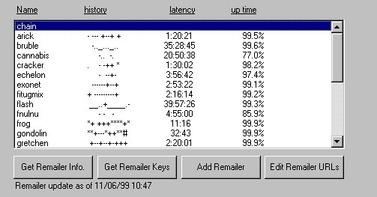
Obtaining the Remailer Keys
Before you can use a remailer you must have the remailer keys on your PGP keyring.. Private Idaho Email will check your PGP Keyring to look for them before trying to send the message anyway. To obtain the keys, select the Type I Remailer from the drop down selection on the Compose Message form. You should the see the Remailer Dialog box shown below pop up. First obtain the remailer list by clicking on the Get Remailer Info button. When this is complete click on the Get Remailer Keys. If this is successful you should be read to proceed to the next step.

Sending a Message Using a Type I Remailer
Click on the button and if you have chain selected, you will be prompted to select as many remailers as you wish. Don't select too many. The first one you select will be the first remailer used, and the last obviously the last in the chain. Once this has been done the message will be transferred to your outbox. If you just wish to use a single remailer, then select the remailer from the list and don't use chain.

Installing and Using Mixmaster (Type II Remailer)
Mixmaster (or Type II) remailers offer a high level of security (see http://www.obscura.com/~loki for complete details). Up until now, Mixmaster has only been available to UNIX users.
Since the Mixmaster client uses export-controlled cryptography, it is not included with Private Idaho. Refer to http://www.obscura.com/~loki for information on how to get a copy of MIXMASTE.ZIP (the compressed version of Mixmaster and its support files).
Mixmaster is availble here ftp://ftp.demon.co.uk/pub/dos/apps/mixmaster/mixmaste.zip
To be able to send messages through Mixmaster remailers you need several files:
MIXMASTE.EXE - the Mixmaster client
MIXMASTE.CON - a support file
PUBRING.MIX - the list of Mixmaster remailer keys
TYPE2.LIS - the list of Mixmaster remailers
MIXMSTR.TXT - statistics on Mixmaster remailers
These files are included in the MIXMASTE.ZIP file. Uncompress the files and move them to directory separate from Private Idaho, e.g. C:\PIMIX. Now because mixmaste.exe is a DOS based executable you now need to set a couple of options so that when Private Idaho calls mixmaste.exe it will be able to 1. Find the appropriate process files 2. Close the DOS window once the processing is done. To set these options, go to the directory where you saved the mixmaster files, and then right click on the mixmaste.exe file. Once you have done this, look for the check box that will tell the operating system to Close on Exit. Click on this checkbox. Also, now make sure that the working directory is pointing to the directory where you installed Mixmaster eg. C:\PIMIX etc.
IMPORTANT: If you choose a different name for the mixmaster directory than that suggested above then make sure that the directory name does not having any spaces in it, and keep it to 8 characters or less.
Using Mixmaster remailers with Private Idaho is no different than using Cypherpunk style remailers. Select Use Type II Remailers from the remailer drop down list. Compose the message and then send the message, depending on the remailers you have chosed, Private Idaho will call Mixmaster, and prepare the message and then send it to your outbox.
You'll need to update information about Mixmaster remailers, just like Cypherpunk remailers. Specifically the PUBRING.MIX, TYPE2.LIS, and MIXMSTR.TXT files.

Sending Attachments through Remailers
When sending an attachment through a remailer, Private Idaho prepares the message in MIME format. The MIME format allows text and attachments to be identified and is a format recognised by most email clients. Because remailers do not understand the MIME format Private Idaho will first produce a MIME message and then encrypt the composite message so that to the Remailers it appears as a single message. See the screenshot below for an example.
Obviously when this is received by another email client it will need to be decoded. Some remailer, Private Idaho included, will attempt to decode it, if this fails, a special utility is privided within Private Idaho. So if you received a message through a remailer that is MIME encoded, click on this button. . If Private Idaho can decode the message it will, if not it will disregard the request.

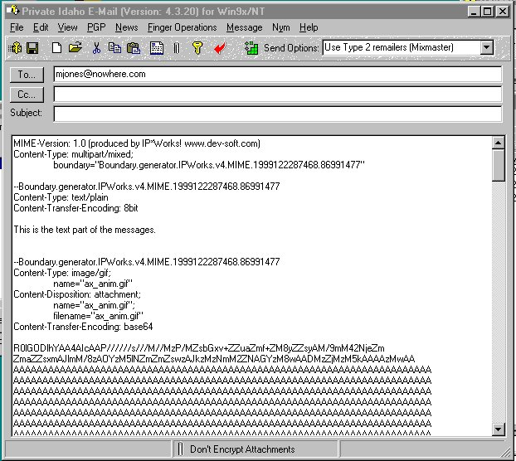
PI32 Specific Features

Creating a Nym

Introduction
The term Nym comes for the word pseudo"Nym". When you create a Nym, you are creating a public email address on a specialised server. For example one service is nym.alias.net. This server allows you to send and receive email pseudonymously through a username of your choice on this server. If, for instance, you choose username <yournym@nym.alias.net>, you will be able to send and receive email at that address, and even get fingered at that address. Nym.Alias.Net can send you a help file by sending an email to help@nym.alias.net (leave the subject and message area blank!)
The system is designed to prevent anyone, even the administrators of the server, from finding out the real person behind any mail alias. If you use this service properly, an adversary will have to compromise mutiple remailers operated by different people in order to find out your real identitiy.
The reply block contains instructions for sending mail to your real E- mail address (or to a newsgroup such as alt.anonymous.messages if you want your mail delivered there). These instructions are successively encrypted for a series of so-called Type-1 remailers in such a way that each remailer can only see the identity of the next hop. To send you an E-mail message (after optionally encrypting it with your nym's PGP key), the server will prepend your reply-block to that message and feed the result directly to the Type-1 remailer <remail@anon.lcs.mit.edu>. [Note that this remailer is reserved for use by nym.alias.net aliases and people debugging their reply-blocks, so you shouldn't see it listed in any of the standard remailer lists.]

Thus, mail you send to nym.alias.net arrives anonymously through the remailer network. Mail you receive from nym.alias.net leaves the server with an encrypted reply block, and can be sent either directly to you or to a message pool such as the newsgroup alt.anonymous.messages. When used properly, therefore, nym.alias.net provides the convenience of an ordinary E-mail address with a strong assurance that your true identity will remain a secret.

Using PI to create a Nym
There are four steps.
- Create a key for the Nym. You need to go to PGP Keys to create a key for Private Idaho and the Nym server to use. PGP Keys is located on the tool bar if you have installed PGP 5 or 6. If not you will need to do that first. Note: You also should bear in mind that most remailers/Nym servers, still use PGP 2.6.x, and as such there is not support for the newer key formats. When you generate your keys to use keylengths equal or less than 1024 and use RSA.
- Now go to the Private Idaho menu, Nyms: Create New Nym. You will now be promped with a series of simple questions. The first is to choose the Nym. If you followed step one above then you will have the name of the Nym. For your first Nym accept all the deault settings.
- Select a remailer you wish to use in your reply block and add the pass phrases you wish to have your remailer use. Remember that these passphrases only protect your message from other remailers reading the embedded forwarding details. Your message is encrypted with your key so this additional encryption does not impact your content but just serves to provided you with additional Nym protection.
- You now need to send the request. DO NOT send it directly to the Nym server. Select a remailer, either mix (Type II) or cypherpunk (Type I). When you get your reply then respond as directed in the message. Remember, that when the message comes back, if you chose to have the Remailers conventionally encrypt it, then you will need to use those phassphrases to decrypt the message. If you wish to get a prompt as to what they were, the go to the Private Idaho menu Nym:Show Nyms.

Converting Existing Nyms
If you have an existing Nym and wish to use it in Private Idaho then, as long the key is on your PGP 5/6 keyring just follow the Nym Create process putting in the details of your existing Nym as you go along. When you get to the end you can send the Nym Create Request as normal, however you will get a response from the Nym Server that states the Nym is already in use. Just ignore this message, however the Nym details will now be Private Idaho.
If you have a key in an earlier version of PGP, for example PGP 2.6.x then you will need to extract the key to a file or the clipboard and then run Private Idaho. Once Private Idaho is running paste the key into the message area and then load it onto your keyring by using the menu command, PGP:Keys:Add Key from message. (show below)

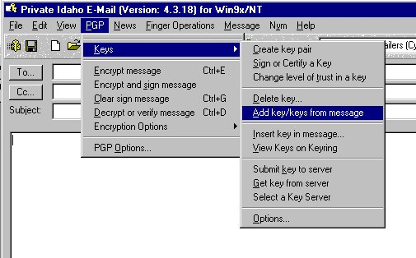
Adding Remailers
To add a remailer simply click on the "Remailer->Add Remailer" menu item. You will then be prompted to type in the address id in similar format to that used by PGP eg.."Mr Remailer <Remailer@jmail.com>." (with out the quotes). If you already have a set of keys for Mr Remailer then place it in the message area of PI32 and then select that option otherwise select the option to create a new set of keys for Mr Remailer. What PI32 does then is to store Mr Remailer into the file PRIVATE.TXT and then invokes PGP to create the keys if necessary. The PRIVATE.TXT is then merged with REMAILER.TXT to give you a consolidated list of remailers. If you invoke the menu "Update Remailers" for the PI32 menu bar, PRIVATE.TXT will be remerged with the updated remailer list. If you wish to remove a remailer you must (at the time of this writing) edit PRIVATE.TXT to remove the entry - this will be automated at a later date.

Scanning for PGP Messages
You can either scan for PGP messages manually or program PI32 to scan for you automatically at minute intervals, ranging from 1 minute to 30,000 minutes. When a message arrives a beep will be heard and the message is stored in your mailbox.

MailBox Facility
The mailbox is simply a database with information on who sent the message, time received, whether there is an attachment etc. The actual email message is not stored in the database but is stored under a special id created by the database, for example a message may have an id of 192393.pim which is the record ID within the database. The name of the attachment is also stored in the database under the actual name of the attachment

How Messages are Stored in the Database
No actual message content is stored in the database and all email stored in the \mailbox directory is stored in the format received, that is if an encrypted (determined by the PGP header) is received it will be stored that way. No decrypted information is stored anywhere by PI. If you wish to store a decrypted file then you must select the PGP:File Options which will prompt you for the location you wish to store the file into. You therefore do not need to worry about unencrypted text being stored in the mailbox. The only way to decrypt a message is manually using the PI32 menu commands. It is then your choice whether to store the plain text on your system or not.

How Attachments are Stored in the Database
Attachments are handled in similar fashion to standard messages in that they are not decrypted. However PI 32 will tell you that an email has an attachment and where that attachment has been stored.

Posting a Newsgroup Message
To post a message to a newsgroup, select News:Newsgroup Reader and fill in the details. The details you enter concerning your news server etc will be saved for your next session. If you wish to attach a file, then go to the File:Attach a File menu. If the file is large, you have the option of splitting it into smaller files. To do this, just enter the size of each segment into the text box and the number of files will be calculated for you. Try and keep the size to a reasonable number. If all the fields are filled and you are happy with the message press the post button and the text and the attachment will be automatically sent for you. See the screen shot below to get an idea of how it works.

